**ELN340 Microcontrollers II**

**Project 1 - User Interface (Multiplexing I/O)**

The first project of this course will involve building a user interface consisting of the Microcontroller, a dual digit 7 segment display and then a keypad matrix.

Part 1 - Display

Output is easier than input so we begin with the dual 7 segment display. Approach this task as follows:

1. Wire and test hardware dual 7 segment common Anode and DIP resistors. Use GPIO 2,0,4,5,16,14,12 for segment control. Don’t wire the inverters yet, simply wire the common anodes to 3.3V. Write a simple program, or the REPL to test the wiring ensuring that you are able to control all 7 segments. Demonstrate the testing of your hardware via streaming video.
2. Program to display digits 0-9 incrementing with a 0.5 second delay. Use a LIST as presented in class containing the 10 X 7 code values.
3. Create a function (displayDigit) which displays the value (0-9) passed to as an argument.
4. Implement dual digit display by including the inverters and wire Digit Select to GPIO 13. Use a programmed delay to display two different digits (constants) simultaneously (20mS delay). Try to use an INPUT function to allow the user to specify the digits to be displayed (instead of the constants). It won’t work because the program stops during the INPUT function.
5. Implement dual digit display using a call-back timer (instead of programmed delay), so that the computer will be free to receive INPUT data simultaneously. Use two global variables to hold the number that is being displayed Msdigit and Lsdigit. Initialize both variables to zero. Receive single digit input from the user. When a new digit is received the Lsdigit is moved to the Msdigit, and the new digit goes into the Lsdigit. Ignore non-numeric characters. If the user enters more than one digit at a time, deal with this situation in your code. Demonstrate the final system using streaming video.

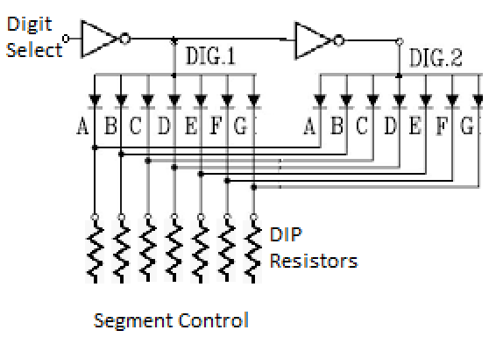

Part 2 - Keypad

The computer will scan one column at a time and test each of the 4 rows for each column (refer to Keypad document).

1. Wired and test hardware simple programs: streaming video demonstration required. Ensure that you are able to describe how the computer can determine which key is being pressed as this will be asked on a test.
2. program to scan one column and determine the row - display the row number (1-4) .
3. Produce a function to scan keypad and return the pressed key (return the key once the finger is lifted from the keypad or return the key on the leading edge of the depressed key -> you decide) . Display the pressed key on the screen. You must include a flowchart to describe the logic of this subroutine.

Deliverables for each part include a description, schematics and well documented program code (as per course outline).

Parts of this project will be included in both a theory and practical test.